

**EXPOSYS DATA LABS**

**INTERNSHIP PROJECT REPORT**

**on**

**UI / UX Designing**

**Submitted by**

**DINESH KUMAR A**

**Register Number: 1BY22MC015**

**MASTER OF COMPUTER APPLICATIONS**

**In**

**BMS INSTITUTE OF TECHNOLOGY AND MANAGEMENT**

**YELAHANKA, BENGALURU – 560064**

**November 2023**

**1.ABSTRACT**

UI/UX design refers to the practice of designing digital products with a user-first approach. It involves creating interfaces that are visually appealing and highly pleasant to interact with, while also ensuring that the product is functional and provides a fantastic experience in terms of performance and navigation. UI and UX are separate disciplines that focus on different aspects of the user's journey with a digital product. The UX designer is responsible for the mechanics of the product, such as its functionality, while the UI designer is responsible for the aesthetics, such as the color, icons, and objects. The user experience design has its base derived from ergonomics, which helps people work more smoothly and efficiently. An abstract is a summary of a UX case study that includes the problem designed for, the goals, the users, the design methods, and the key results or outcomes for the users. Abstract is a platform for designers and design teams to manage projects and have version control. It is a tool that is almost similar to GIT and is available only for Mac users who use Sketch as their design tool. The best thing about Abstract is that they are continuously working on improving the tool to give the best experience to their users.

Typically, the UX Design process include:

1.Research

2.Usability

3.Utility

4.Accessibilty

5.Design/Aesthetics

6.Performance

7.Human Interaction and Marketing

On the other hand, User Interface (UI) is more about visual design and information design around screens. Though a lot of process go into this graphical element, UI as the name implies, about the things the user will actually see and interact. It delivers tangible results and focuses on how an app or product surface look and functions.

1. Anticipating what users might need to do and

2. Ensuring that the interface has elements that are easy to access,understand, and use to facilitate those actions.

**2. Table of Contents**

2.1. About us

2.2. Exposys Data Labs Virtual Internship Program

1. Data Science
2. Web Development
3. Full Stack Development
4. Mobile App Development
5. Software Development
6. IOT (Internet Of Things)
7. UI/UX Designing
8. Cyber Security
9. Digital Marketing
10. Content Writing
11. Human Resource (HR)
12. Digital Media Promotor
13. Business Development Associate
14. Process Associate
15. Contact Info

2.3. Introduction

2.4. Methodology

2.5. Proposed Method

2.6. Implementation

2.7. Conclusion

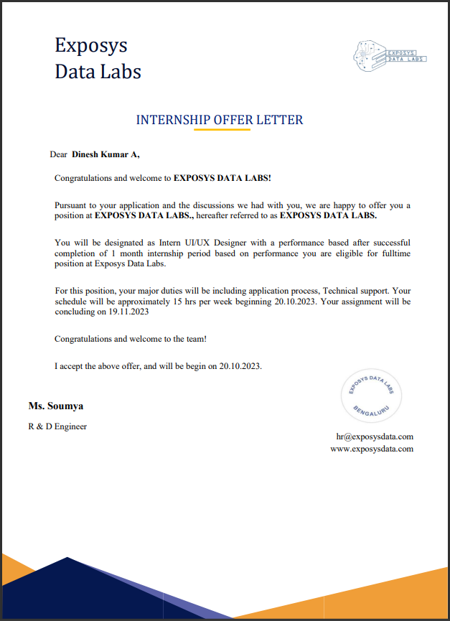

**3. Introduction**

Exposys Data Labs Aims To Solve Real World Business Problems Like Automation, Big Data And Data Science. Our Core Team Of Experts In Various Technologies Help Businesses To Identify Issues,Oppurtunities And Prototype Solutions Using Trending Technologies Like AI, ML, Deep Learning And Data Science. We Follow A Human-Focussed And Not Technology Driven Approach To Achieve Success In Our Clients Endeavours.

Exposys Data Labs offers an internship program that provides students with real-time projects to work on, mini project assignments, and report submissions. The program lasts from one week to six months, and students are given a stipend based on their performance. Upon completion of the program, students receive an internship certificate and may be offered full-time employment based on their performance.

**4. Methodology**

After defining objectives and planning research framework, it’s time to choose the research technique that will best serve project's goals and yield the right insights. While user research is often treated as an afterthought, it should inform every design decision. The most common research methods are:

1. User interviews are a qualitative research method that involves having open-ended and guided discussions with users to gather in-depth insights about their experiences, needs, motivations, and behaviors.

Start with a wide context: Make sure that your questions don’t start with your product

Ask questions that focus on the tasks that users are trying to complete

Invest in analysis: Get transcripts done and share the findings with your team

2. Field studies are research activities that take place in the user’s environment rather than in your lab or office. They’re a great method for uncovering context, unknown motivations, or constraints that affect the user experience.

An advantage of field studies is observing people in their natural environment, giving you a glimpse at the context in which your product is used. It’s useful to understand the context in which users complete tasks, learn about their needs, and collect in-depth user stories.

3. A focus group is a qualitative research method that includes the study of a group of people, their beliefs, and opinions. It’s typically used for market research or gathering feedback on products and messaging.

* Focus groups can help you better grasp:
* How users perceive your product
* What users believe are a product’s most important features
* What problems do users experience with the product

4. Diary studies involve asking users to track their usage and thoughts on your product by keeping logs or diaries, taking photos, explaining their activities, and highlighting things that stood out to them.Remember to determine the trigger: a signal that lets the participants know when they should log their feedback. Tanya breaks these triggers down into the following:

* Interval-contingent trigger: Participants fill out the diary at specific intervals such as one entry per day, or one entry per week
* Signal-contingent trigger: You tell the participant when to make an entry and how you would prefer them to communicate it to you as well as your preferred type of communication
* Event-contingent trigger: The participant makes an entry whenever a defined event occurs.

5. Although surveys are primarily used for quantitative research, they can also provided qualitative data, depending on whether you use closed or open-ended questions:

1. Closed-ended questions come with a predefined set of answers to choose from using formats like rating scales, rankings, or multiple choice. This results in quantitative data.
2. Open-ended questions are typically open-text questions where test participants give their responses in a free-form style. This results in qualitative data.

Make sure your questions:

* Are easy to understand
* Don't guide participants towards a particular answer
* Include both closed-ended and open-ended questions
* Respect users and their privacy
* Are consistent in terms of format

6. Card sorting is an important step in creating an intuitive information architecture (IA) and user experience. It’s also a great technique to generate ideas, naming conventions, or simply see how users understand topics.

There are three types of card sorting:

* Open card sorting: Participants organize topics into categories that make sense to them and name those categories, thus generating new ideas and names
* Hybrid card sorting: Participants can sort cards into predefined categories, but also have the option to create their own categories
* Closed card sorting: Participants are given predefined categories and asked to sort the items into the available groups

7. During tree testing a text-only version of the site is given to your participants, who are asked to complete a series of tasks requiring them to locate items on the app or website.The data collected from a tree test helps you understand where users intuitively navigate first, and is an effective way to assess the findability, labeling, and information architecture of a product.

8. Usability testing evaluates your product with people by getting them to complete tasks while you observe and note their interactions (either during or after the test). The goal of conducting usability testing is to understand if your design is intuitive and easy to use. A sign of success is if users can easily accomplish their goals and complete tasks with your product.The tasks you create for usability tests should be:

* Realistic, and describe a scenario
* Actionable, and use action verbs (create, sign up, buy, etc)

9. In five-second testing, participants are (unsurprisingly) given five seconds to view an image like a design or web page, and then they’re asked questions about the design to gauge their first impressions.

Why five seconds? According to data, 55% of visitors spend less than 15 seconds on a website, so it;s essential to grab someone’s attention in the first few seconds of their visit. With a five-second test, you can quickly determine what information users perceive and their impressions during the first five seconds of viewing a design.

10. A/B testing, also known as split testing, compares two or more versions of a webpage, interface, or feature to determine which performs better regarding engagement, conversions, or other predefined metrics.

It involves randomly dividing users into different groups and giving each group a different version of the design element being tested. For example, let's say the primary call-to-action on the page is a button that says ‘buy now’.

11. Concept testing is a type of research that evaluates the feasibility, appeal, and potential success of a new product before you build it. It centers the user in the ideation process, using UX research methods like A/B testing, surveys, and customer interviews.

There’s no one way to run a concept test—you can opt for concept testing surveys, interviews, focus groups, or any other method that gets qualitative data on your concept.

**5. Proposed method**

* Define the project and scope
* Conduct research on users and competition
* Analyze the research results
* Create a rough draft of the solution
* Design the product, adapting it to various screen sizes and devices
* Prototype and test the design to ensure it works as intended
* Implement the solution onto a webpage or other platform
* Evaluate the work and iterate as necessary

UI\UX plays an important role in marketing and advertisement. There are various advantages mentioned below about the same:

* Creating a positive user experience: UX design focuses on creating high-converting marketing experiences that customers want and need. Great UX delights customers and creates loyal customers who are more likely to become repeat customers, provide valuable feedback, and advocate for the brand.
* Differentiating the brand from competitors: Exceptional UX/UI design helps businesses differentiate themselves from competitors. By providing superior user experiences, businesses can carve a distinct identity and position themselves as industry leaders.
* Tailoring content and recommendations based on user preferences: UX/UI design allows businesses to deliver personalized experiences by tailoring content and recommendations based on user preferences and behaviors. By understanding user behaviors, preferences, and pain points, businesses can tailor their digital marketing strategies to deliver personalized and impactful experiences.
* Improving conversion rates: UX design can help marketers identify snags and points of friction in their conversion funnel. By identifying and removing blockages in the conversion funnel, marketing specialists can improve the performance of existing campaigns and increase conversion rates.
* Supporting existing users and attracting new customers: UX and marketing teams have some overlaps in their approach to supporting existing users or attracting new customers. By designing a persona for current users who are also potential customers for new products, businesses can align their UX and marketing efforts to deliver a seamless and fluid user experience.

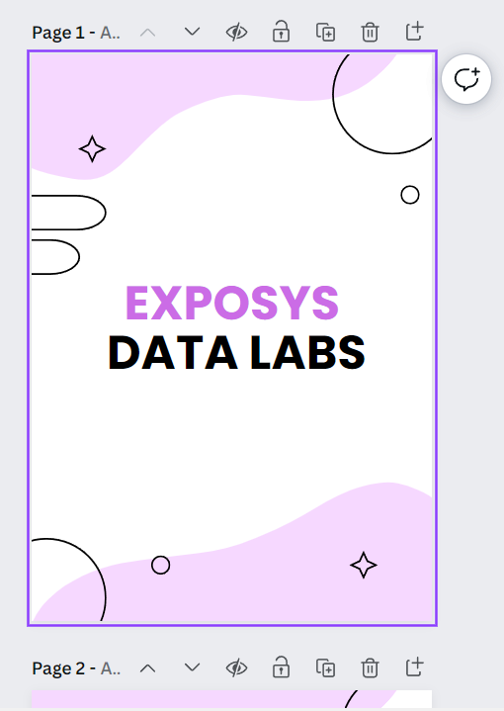

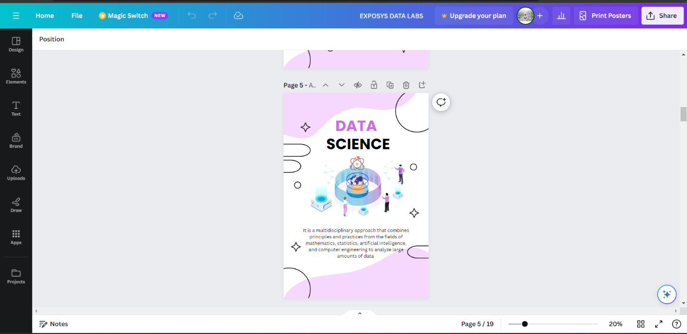

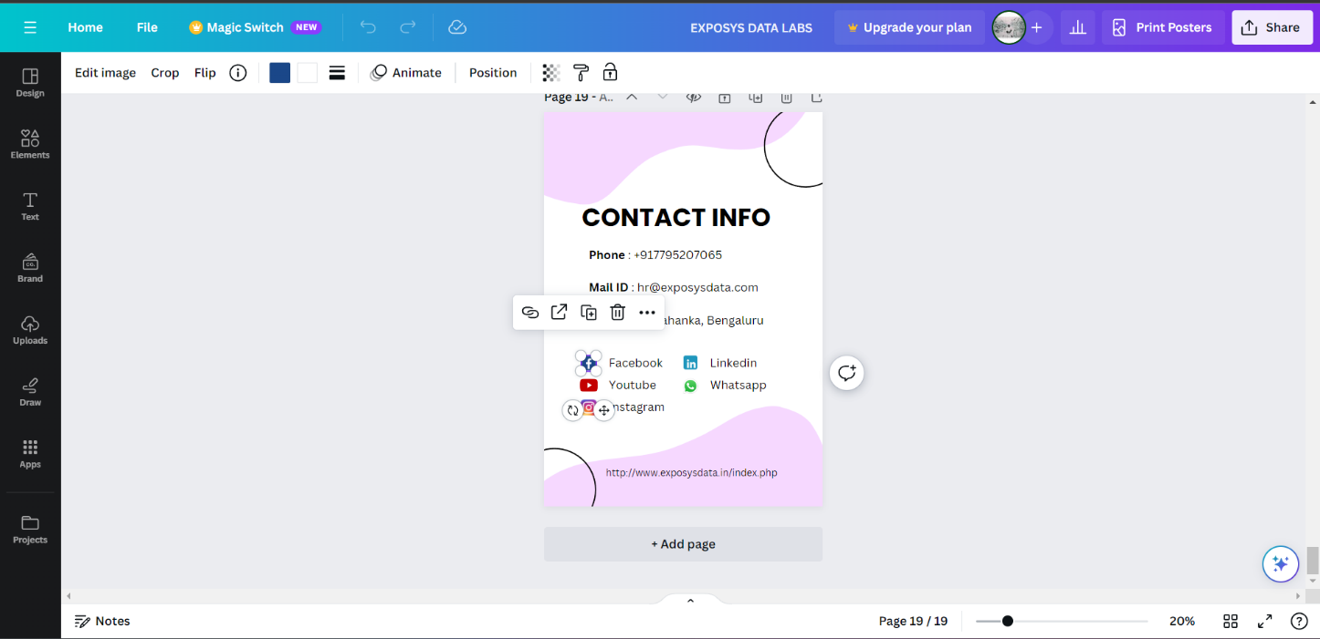

**5. Implementation**

For this particular project a tool called canva was used as it has pre defined templates, shapes, fonts, shapes, graphics and a user friendly interface to design posters to market the internship programs offered by Exposys Data Labs in various domains.

Define the purpose and scope of the poster: Before designing the poster, it is essential to understand its purpose and scope. Determine the message you want to convey and the target audience.

**Choose a template**: There are various templates available online, such as those from Canva, Venngage, and Visme. Choose a template that best fits the purpose of your poster.

**Customize the template**: Once you have selected a template, customize it to suit your needs. You can change the text, font, color, and images to match your internship report's theme and content.

**Add images and graphics**: Adding images and graphics can enhance your poster's visual appeal. You can use free vector graphics and clip art available online, such as those from Vecteezy.

**Review and edit**: After designing your poster, review it to ensure that it meets your requirements. Edit it as necessary to make it more visually appealing and informative.

**Print and share**: Once you are satisfied with your poster, print it out or share it digitally on social media platforms or email.

**6. Conclusion**

The industry training program provided me an opportunity to have a detailed and practical study of the various process followed in the industry. Basic information about the industry was imparted and the research on current trends led to enriching our knowledge. The process of developing UI Designs and Mock Sites & Co-ordinating with the development team was made aware of during this internship. Working under the design head of the industry, covering the entire Design process , gave me an experience never to forget about and provided me with lots of useful information that will be useful in my career ahead.